ML-Based Quantum Control Schemes

1. Problem
Quantum control concerns the task of steering a quantum system from an initial state to a desired target state or operation using external control fields (e.g., laser pulses, microwave signals, voltages).
Classical control techniques struggle with: - High-dimensional Hilbert spaces - Noise and decoherence - Nonlinear system dynamics
Machine Learning (ML)-based quantum control uses learning algorithms to automatically discover effective control strategies for quantum systems.

2. Intuition
Instead of analytically designing control pulses, ML-based quantum control:
- Treats the quantum system as a black box or differentiable simulator
- Uses feedback (fidelity, error, reward) to improve controls
- Learns robust pulse shapes or gate sequences
ML can adapt to noise and experimental imperfections better than hand-crafted control laws.

3. Algorithm / Control Structure
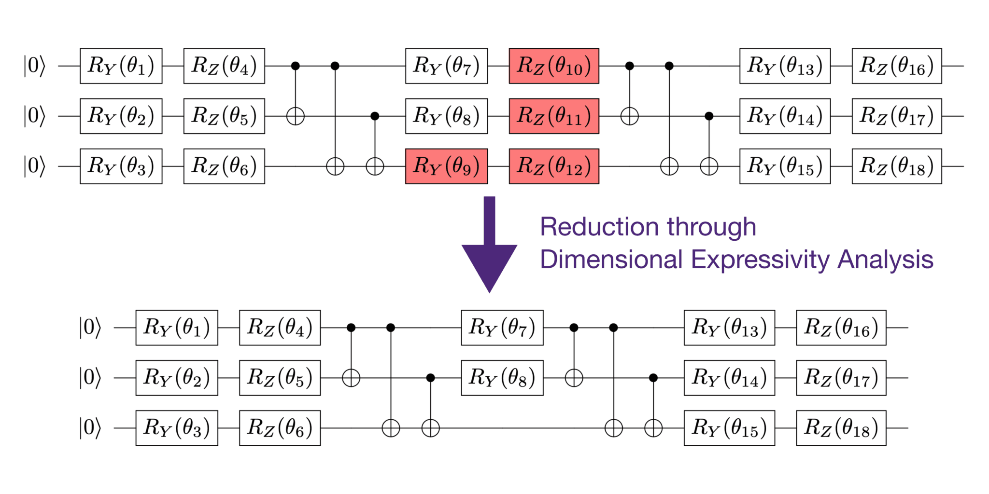
A typical ML-based quantum control loop consists of:
- State Preparation
Initialize the quantum system.sssss
- Parameterized Control (Agent / Model)
ML model generates control parameters (pulse amplitudes, phases, durations).
- Quantum Evolution
System evolves under the applied controls.
- Measurement & Evaluation
Compute fidelity or cost function.
- Learning Update
ML algorithm updates control parameters.
This forms a closed-loop hybrid quantum–classical system.

4. Simple Math Involved
- Controlled Schrödinger equation: [ i|(t)= (H_0 + _k u_k(t) H_k)|(t) ]
- Objective (fidelity): [ F = |_{} | (T) |^2 ]
- Optimization goal: [ _{u(t)} F ]

5. Python Code (ML-Based Quantum Control – Qiskit-Style Example)
Educational execution code illustrating learning-driven control
import numpy as np
from qiskit import QuantumCircuit
from qiskit.primitives import Sampler
# ---------------------------------
# 1. Simple controllable quantum system
# ---------------------------------
qc = QuantumCircuit(1)
# Trainable control parameters (example)
params = np.random.rand(3)
qc.rx(params[0], 0)
qc.ry(params[1], 0)
qc.rz(params[2], 0)
qc.measure_all()
# ---------------------------------
# 2. Evaluate control performance
# ---------------------------------
sampler = Sampler()
result = sampler.run(qc, shots=512).result()
probs = result.quasi_dists[0]
# Fidelity proxy (maximize |0>)
fidelity = probs.get('0', 0)
print("Control fidelity estimate:", fidelity)

6. Where the Algorithm Is Useful
- Quantum gate calibration
- Pulse-level control
- Noise-resilient quantum operations
- Quantum hardware optimization

7. Limitations
- Requires many experiments or simulations
- Training can be slow
- Sensitive to hardware noise
- Scalability challenges

8. Comparison with Classical Quantum Control
- Design: Analytical pulses vs ML-learned pulses
- Adaptability: Fixed vs adaptive to noise
- Automation: Manual tuning vs autonomous learning
- Maturity: Classical methods are mature; ML-based methods are emerging

9. One-Sentence Summary
ML-based quantum control uses learning algorithms to automatically discover high-fidelity control strategies for quantum systems.

